Project Phase 2

Programming a java IF statement

IS420

Dustin Tripp 2021

How to unzip and run the program

* Strongly encouraged ( This paper does not explain it well. )*

# Download the file

# Unzip the file and store it on your system

# Click on the “index.html” file and open in any web browser (preferably chrome)

# Enjoy the website!!

Home page

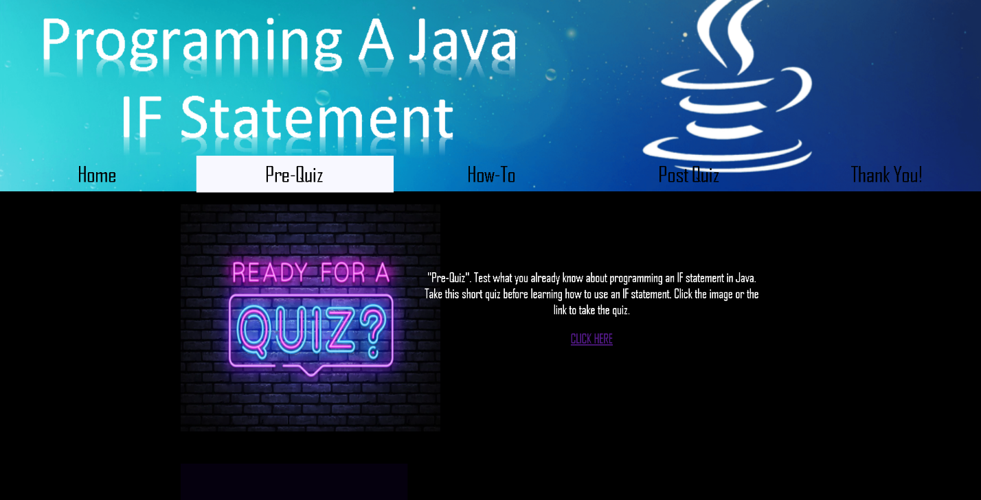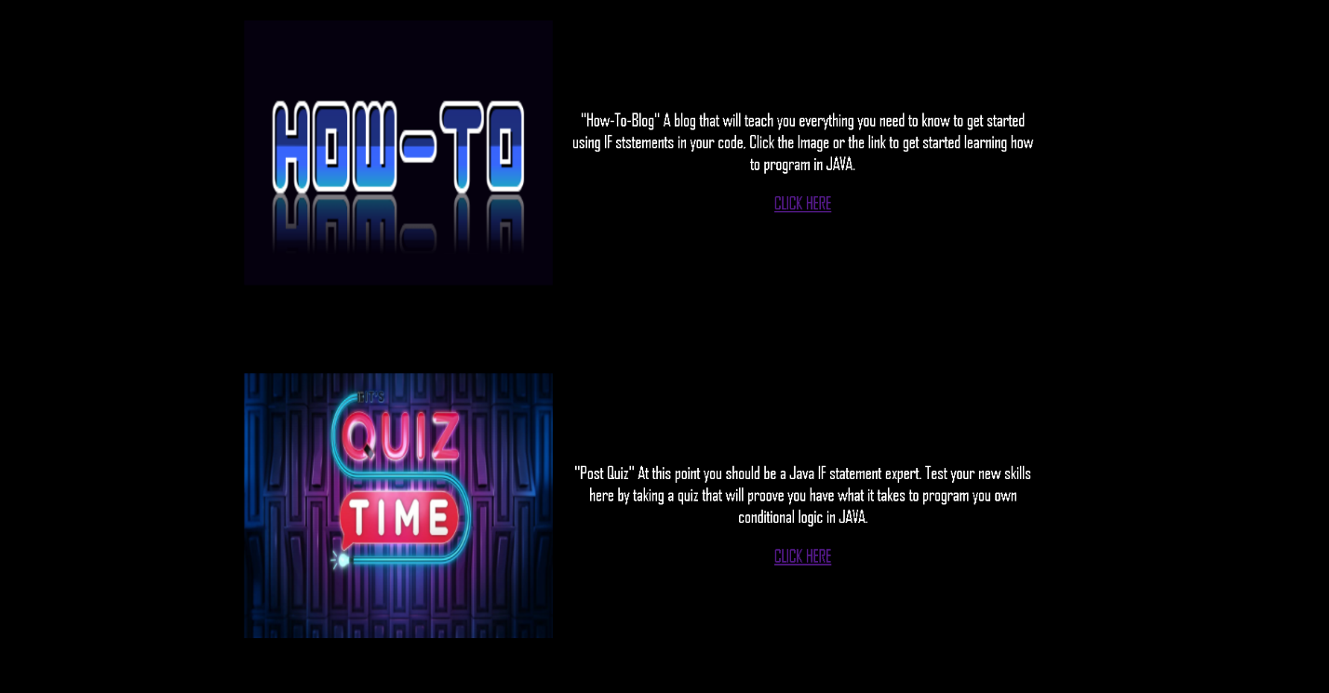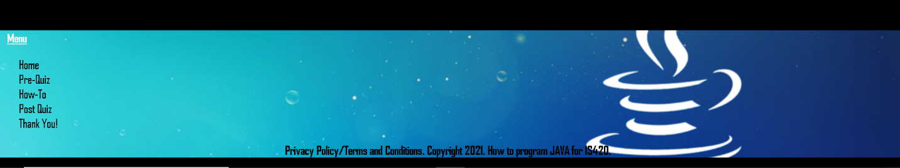

Home page description

* Each picture is a link to that part of the website
* Each link corresponds to the correct part of the website
* There is both a top navigation bar and a lower navigation bar

Pre Quiz Page / Post Quiz page

**Before taking the quiz

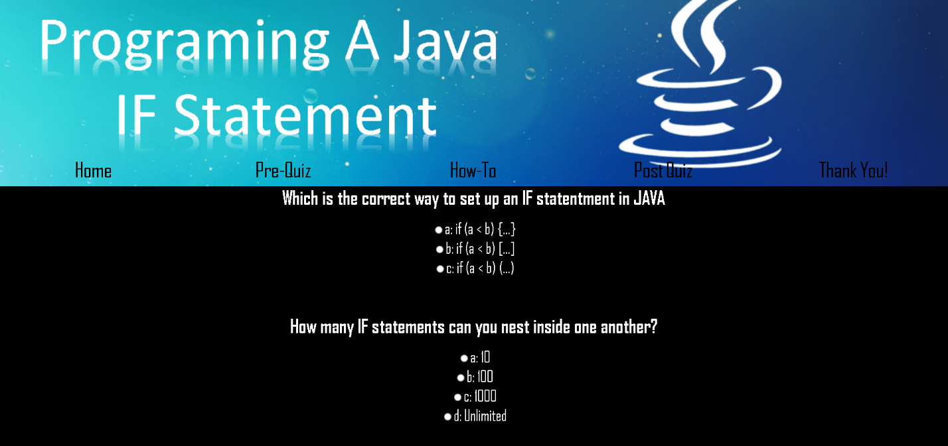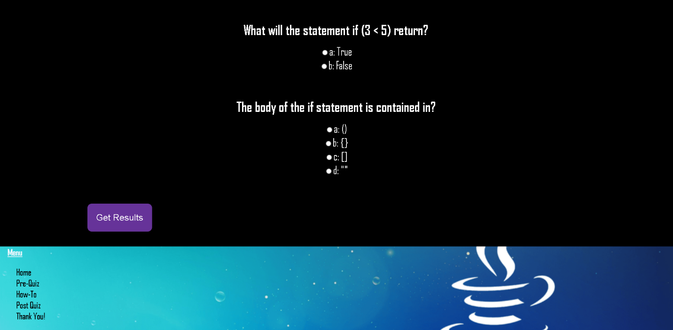

** After taking the quiz

How to page

